Use-Case Realization Report (Design)
Add Section

Issue <1.0>
Revision History
Date | Issue | Description | Author
<15/Sep/09> | <1.0> | <Initial version> | <Thomas Yap>

Table of Contents
1. Brief Description 4
2. Flow of Events 4
3. Flow of Events 4
3.1.1 Add Exam 4
4. Interaction Diagrams 5
4.1 Collaboration Diagram for Add Section 5
4.2 Sequence Diagram for Add Section 6
5. Participating Objects 6
6. Class Diagrams 7
6.1 Class Diagram for Add Section 7
7. Derived Requirements 7

Use-Case Realization Report
Add Section

Brief Description
This use case enables the controller to add new section to exam. It involves displaying the menu and form for keying in the section details.

Flow of Events
The standard flow of events for this use case and any exceptions are described in the following subsections. The events are described in terms of Actors and Design Objects.

Flow of Events
This use case covers the Section Maintenance - Add Section. The standard flow of these events is described below.

Add Section
The running of the application is shown in section 3.1. The flow of event is as follow:

- When the application start, the first operation to be performed is the startup operation of the main controller. This operation will create all the control objects and the entity objects necessary for operation Add Exam:
  - The control object created is: MCQBL Controller
  - The entity object create are: mcq_exam_master and mcq_section_master.

- The main controller will start the main function menu:
  - To start Add Section, operation page_load() is activated by MCQBL Controller to display an Section form.
  - Portal Admin then input the data.
  - Operation validation will validate the format of the entries.
  - Then MCQBL Controller will check for duplication.
  - If no issue found, MCQBL Controller will send a confirmation request to form Section Interface.
  - Upon confirmation, the data will then be written to table using operation InsertSection() to entity object mcq_exam_master and mcq_section_master.
  - The adding request can be cancelled by clicking cancel button and no data will be storred.
  - A confirmation message will be displayed by form Section interface.

- Step 2 will be repeated until all new entries are added to the system. Then controller will terminate the application by issuing operation close.

Interaction Diagrams

Collaboration Diagram for Add Section
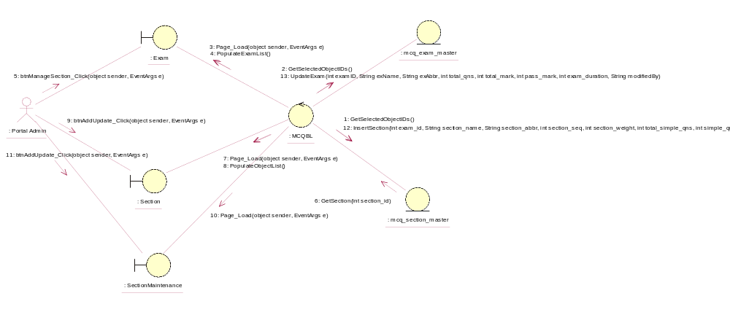

Sequence Diagram for Add Section
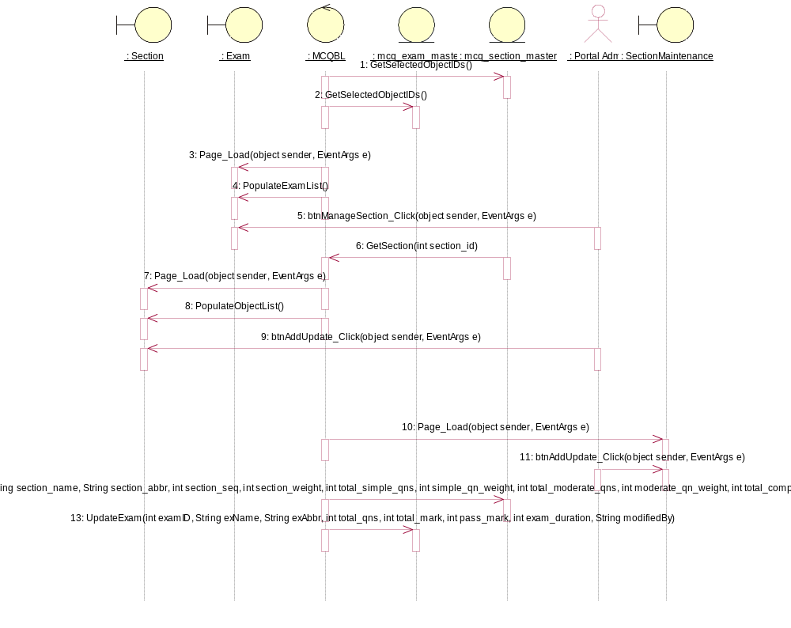

Participating Objects
: Exam

: mcq_exam_master

: mcq_section_master

: MCQBL

: Portal Admin

: Section

: SectionMaintenance

Class Diagrams

Class Diagram for Add Section
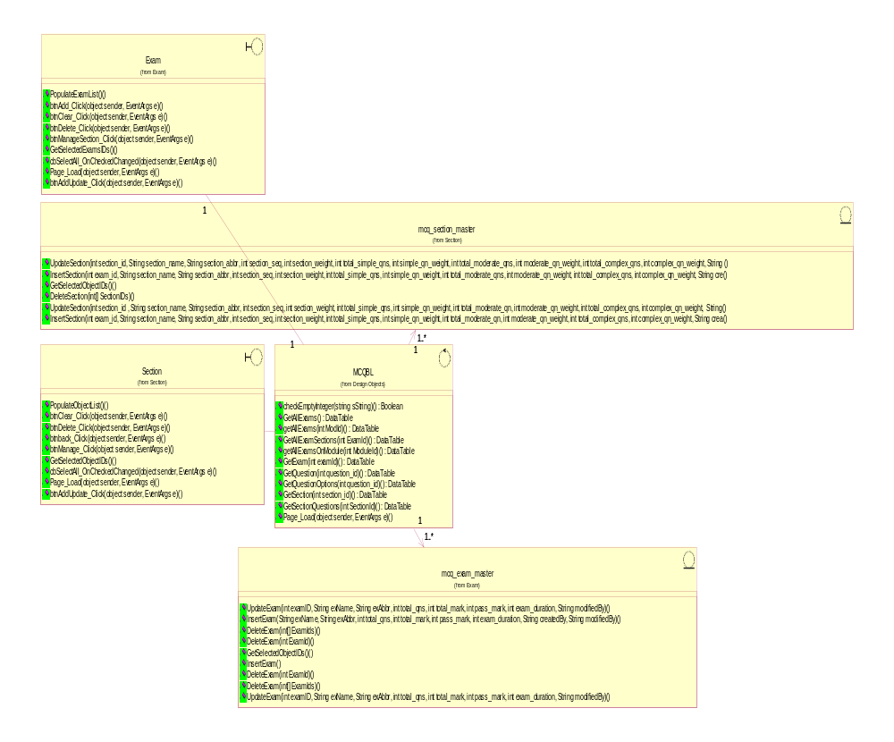

Derived Requirements
[enter the derived requirements here]

